**Pipes**

Using built-in Angular pipes

* Open Visual Studio Code
* Set product name to uppercase using in-built pipe in *Product-list.component.html*.

<td [style.color]="'#306A9D'" [style.font-weight]="700" [style.font-size.px]="20">

{{ product.productName | uppercase }}

</td>

**Output:**

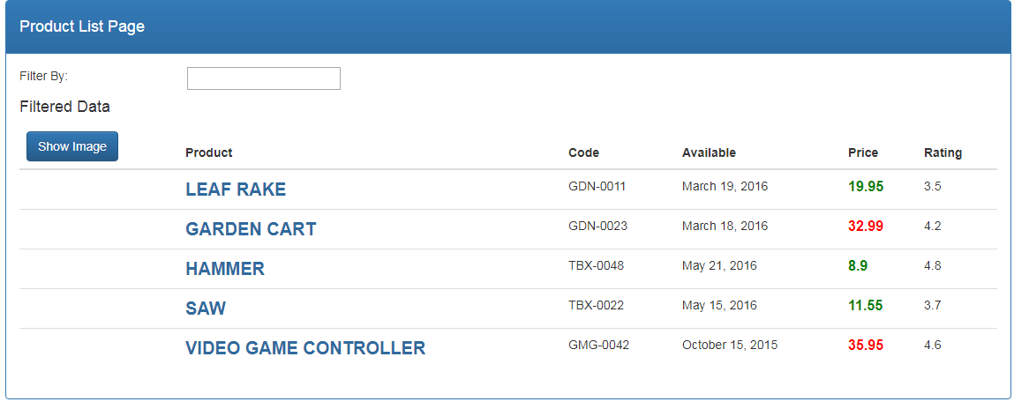

Using custom Angular pipes

* Create a new file called *convert-to-spaces.pipe.ts***.**

import { Pipe, PipeTransform } from "@angular/core";

@Pipe({

name: 'convertToSpaces'

})

export class ConvertToSpacesPipe implements PipeTransform{

transform(value:string, character:string, ) {

return value.replace(character, '@');

}

}

* Import *convert-to-spaces.pipe.ts* to *app.module.ts* and declare it inside declaration array.

import { ConvertToSpacesPipe } from 'src/app/products/convert-to-spaces.pipe';

declarations: [

AppComponent,

ProductListComponent,

ConvertToSpacesPipe

]

* Add the following code in *Product-list.component.html*.

<td>{{ product.productCode | convertToSpaces:'-'}}</td>

**Output:**

